**Resume**

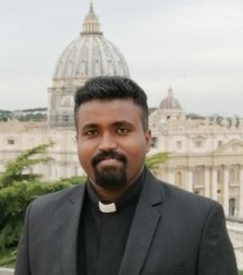

**Priest’s name:** Rev.Fr. Arokia Anthony. D

**Date of Birth:** 17/07/1990

**Place of Birth:** Bhadravathi, Karnataka **Date of Ordination:** 16/07/21 **Diocese:** Archdiocese of Bangalore

**Priestly Moto:** To live in His grace, is the joy of life.

**Vision & Mission:** To be a blessing for all.

**Pastoral ministry:** 1.Asst. Parish Priest

Prabha Tara Church, Taragarh, Diocese of Jashpur, Chhattisgarh.

(Mission experience)

2. Asst. Parish Priest

Sacred Heart Church,

Richmond Road,

Bangalore.

3. Asst. Parish Priest

St. Joseph Vaz Church,

Shimoga Diocese

(Mission experience)

3. Asst. Parish Priest

St. Joseph’s Church,

Briand Square,

Chamarajpet

Bangalore

# Qualification:

1. Primary & High School: BalaYesu Vidyalaya, Viveknagar, Bangalore.
2. PUC: St. Aloysius College, Cox town, Bangalore.
3. Graduation: B. Com, St. Joseph’s Evening College, Museum Road, Bangalore.

# Seminary Formation:

1. Bhakti Bhavan Archdiocesan Minor Seminary.
2. St. Joseph’s Interdiocesan Seminary, Jeppu, Mangalore.
3. Pontifical Urban College, Rome, Italy.

# Ecclesiastical Studies:

1. BPh: St. Joseph’s Interdiocesan Seminary, Mangalore (2011-2014).
2. BTh: Pontifical Urbaniana University, Rome, Italy (2015-2018).
3. MTh: (Licentiate in Theology, specialized in Moral): Pontifical Urbaniana University, Rome, Italy (2018-2020).

Thesis – Sexual Anthropology and Moral implications

**Other Qualifications:** Diploma in Priestly formation Course from the Congregation for the Clergy, Rome, Italy (2019-2020).

**Field of interests:** Fundamental Ethics, Family Ethics and Social Ethics.

**Languages known:** Kannada, Tamil, Hindi, English, Italian, and German.

**Contact Number:** +917760894702

**E-mail:** [arokiaanthony6@gmail.com](mailto:arokiaanthony6@gmail.com)

Rev.Fr. Arokia Anthony. D